Manufactured solution for DSM2-STM verification
Governing equation:
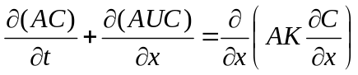
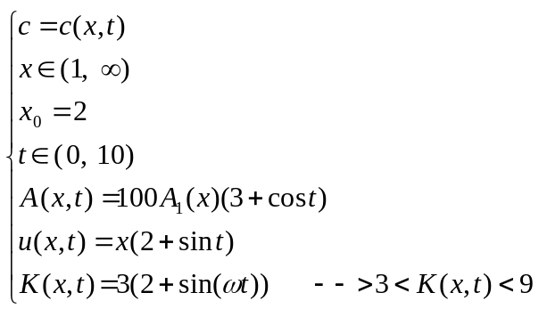
A₁(x) will derive base on mass conservation
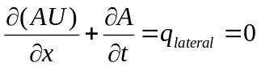
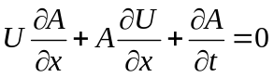
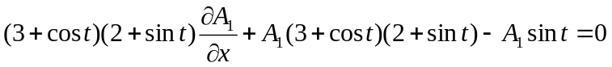
Solving A₁ with symbolic math:
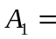

No restriction on the boundary condition and initial condition, they will be appear automatically after choosing the function for manufactured solution
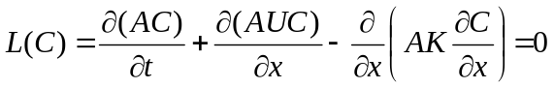
The above is governing equation in a very general form (area, velocity and dispersion coefficients are function of time/space), since the method of manufactured solution is a general concept, any solution for C can be picked regardless of the governing equation
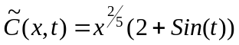
It seems the function which is picked for MMS must not vanish in governing equation, so for Advection Diffusion, C must be from at least from C¹ space in x domain and C⁰ space in time domain (the above C is always smooth or belongs to C∞ space in both t and x)
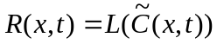

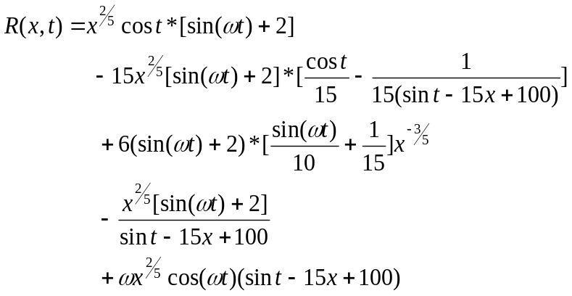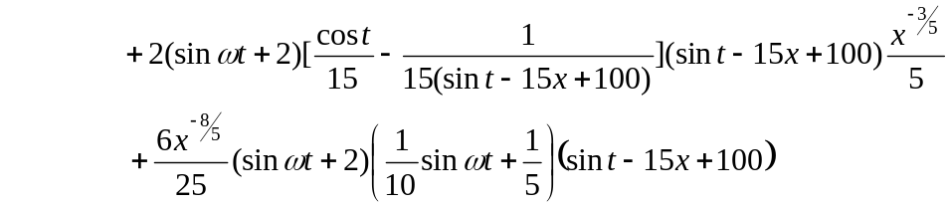

So the modified equation is:
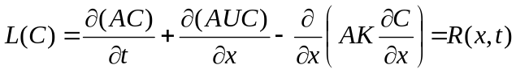
Subjected to the initial condition:
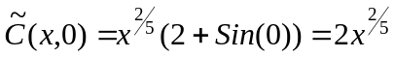
And the Neumann - Neumann (no out flow gradient) boundary condition:
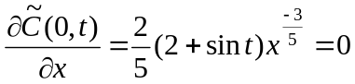
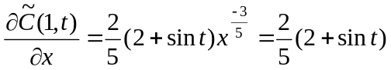

Appendix

Symbolic Math results for copy paste into FORTRAN

A = sin(t) - 15*x + 100

U =cos(t)/15 - 1/(15*(sin(t) - 15*x + 100))

K =sin(t*w)/10 + 1/5

C = x^(2/5)*(sin(t*w) + 2)

L = diff(A*C,t)+diff(A*U*C,x)-diff(A*K*diff(C,x) ,x)

L =

x^(2/5)*cos(t)*(sin(t*w) + 2) - 15*x^(2/5)*(sin(t*w) + 2)*(cos(t)/15 - 1/(15*(sin(t) - 15*x + 100))) + (6*(sin(t*w) + 2)*(sin(t*w)/10 + 1/5))/x^(3/5) - (x^(2/5)*(sin(t*w) + 2))/(sin(t) - 15*x + 100) + w*x^(2/5)*cos(t*w)*(sin(t) - 15*x + 100) + (2*(sin(t*w) + 2)*(cos(t)/15 - 1/(15*(sin(t) - 15*x + 100)))*(sin(t) - 15*x + 100))/(5*x^(3/5)) + (6*(sin(t*w) + 2)*(sin(t*w)/10 + 1/5)*(sin(t) - 15*x + 100))/(25*x^(8/5))

